Bike Rentals

Neural Network

Presented By

Benjamin Hinchman

Jesse Gibbons

Kyle Tolliver

Richard Kung

Shane Mecham

# Analysis Overview

Our neural network predicts total bike rentals for a given hour based on the information from the database. It rarely overpredicts more than 25 bikes for an hour, but can underpredict as many as 75 bikes for an hour.

We also did some analysis of the data you gave us. Given that total bikes rented tends to decrease during holidays, and your busiest hours are 5pm and 6pm, most of your customers probably use your services to commute from work. Every feature you provided is essential in predicting the number of bicycles rented at a given hour. Weather and time of day are especially telling.

One key feature of one of our learning models was to normalize nearly all of the data and to remove any unnecessary values. For instance we removed the instance column and the dteday column as they were extraneous to the test we were trying to do and normalizing them would have required far more work. We normalized the seasons column and the weathersit column with one hot encoding. Doing this and experimenting with different levels of dropout between the different layers provided far greater accuracy for the predictions.

# Conclusions and Caveats

In conclusion, while we were accurate with our findings we do have the problem that our neural network is trained to predict an hour at a time. To predict for any given day, sum the output for each hour of the predicted day.

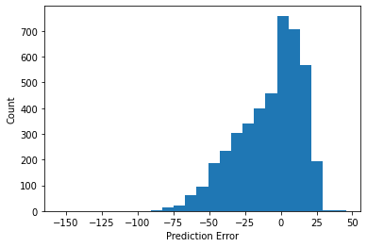

Prediction error (error in the total number of bikes sold in a given hour)

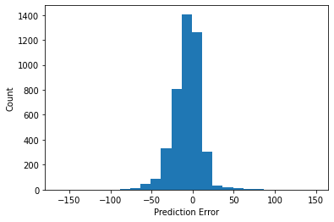

# Notebooks used

<https://colab.research.google.com/drive/1TwgVoquL7DSekO3FzciS2_bKa08WyQJy?usp=sharing>

<https://colab.research.google.com/drive/1255i1soOxC1DSZlMPjOuDzytRUhlwTgI?usp=sharing>

<https://gist.github.com/Detroitiron/d1474734481f140ab4932a24bd587fac#file-module-05-ipynb>